**Ideation Phase**

**Define the Problem Statements**

|  |  |
| --- | --- |
| Date | 1 September 2022 |
| Team ID | PNT2022TMID54057 |
| Project Name | Nutrition Assistant Application |
| Maximum Marks | 2 Marks |

**Customer Problem Statement Template:**

Create a problem statement to understand your customer's point of view. The Customer Problem Statement template helps you focus on what matters to create experiences people will love.

A well-articulated customer problem statement allows you and your team to find the ideal solution for the challenges your customers face. Throughout the process, you’ll also be able to empathize with your customers, which helps you better understand how they perceive your product or service.

Reference: <https://miro.com/templates/customer-problem-statement/>

**Example:**

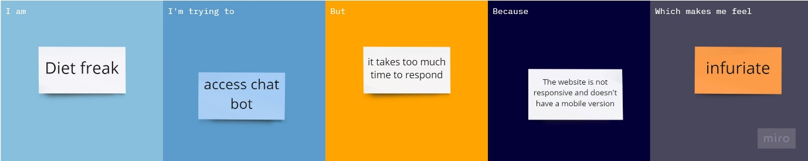

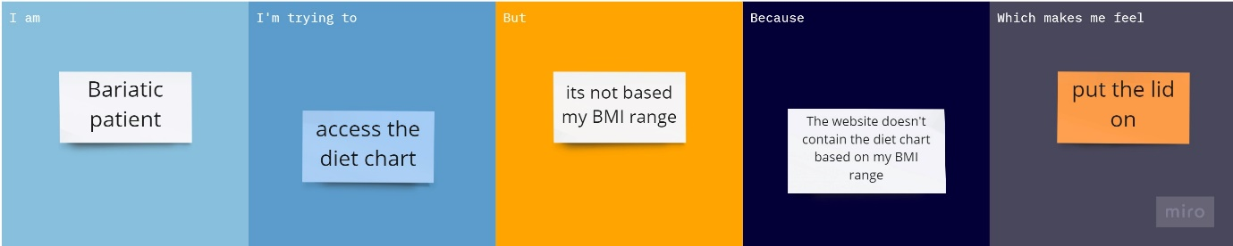

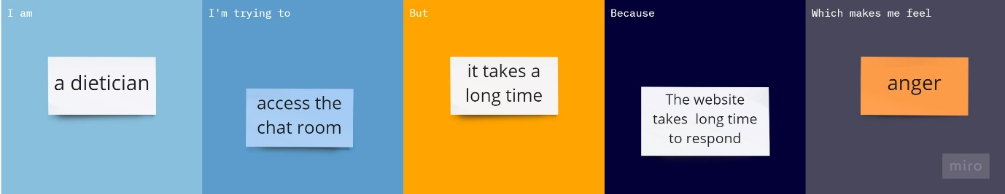

|  |  |  |  |  |  |
| --- | --- | --- | --- | --- | --- |
| **Problem Statement (PS)** | **I am (Customer)** | **I’m trying to** | **But** | **Because** | **Which makes me feel** |
| PS-1 | Diet freak | Access chat bot | Its take too much time to respond | The website is not responsive and doesn’t have a mobile version | Infuriate. |
| PS-2 | Bariatic patient | Access the diet chart | Its not based on my BMI range | The website doesn’t contain the diet chart based on my BMI range | Put the lid on. |
| PS-3 | Dietician | Access the chat room | It takes a long time | The website takes long time to respond | Anger. |